**ACKNOWLEDGEMENT**

**PRACTICAL EXERCISE-1A**

**Q: Write a program to find the factorial**

**PROGRAM: -**

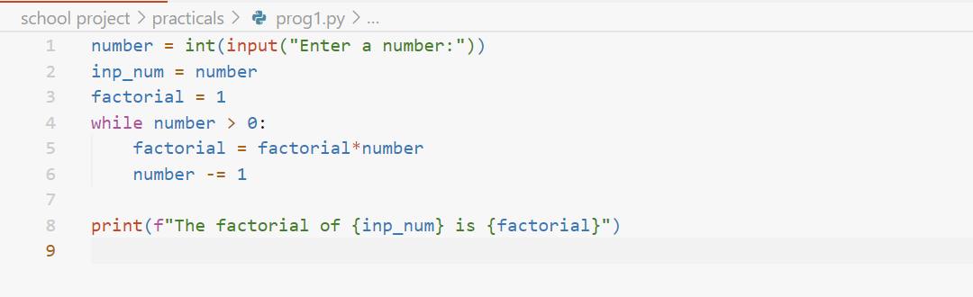

**OUTPUT: -**

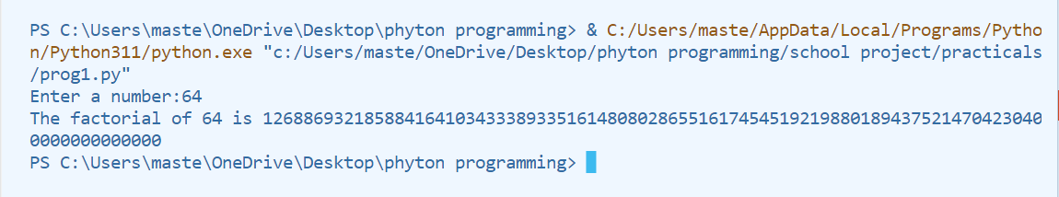

**PRACTICAL EXERCISE-1B**

**Q: Write a program to check if a number is prime or not prime**

**PROGRAM: -**

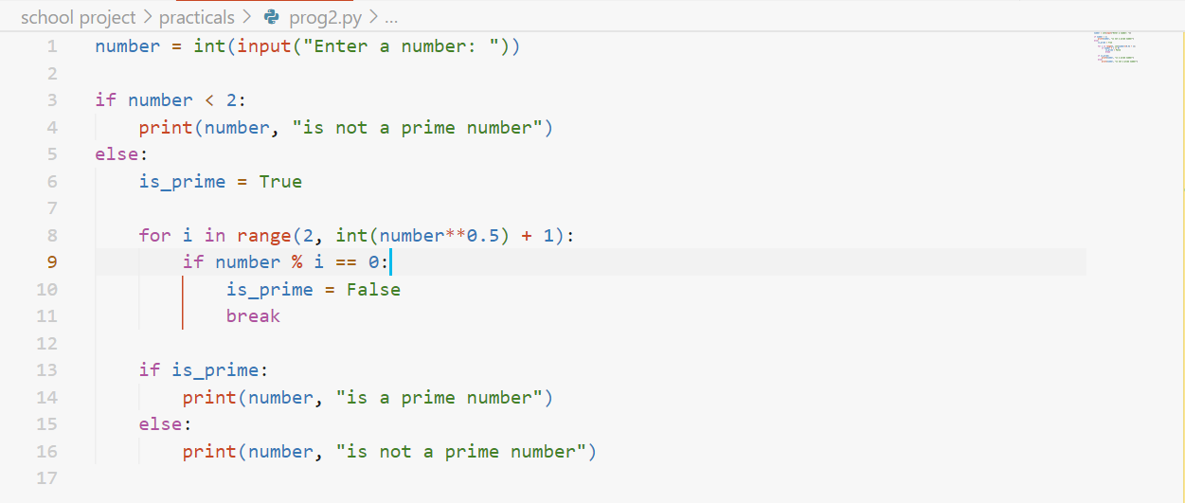

**OUTPUT: -**

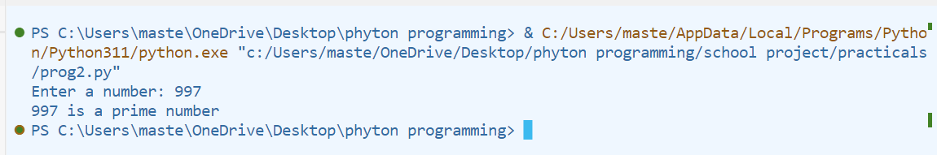

**PRACTICAL EXERCISE-2**

**Q: Write a program to find the sum of a list recursively**

**PROGRAM: -**

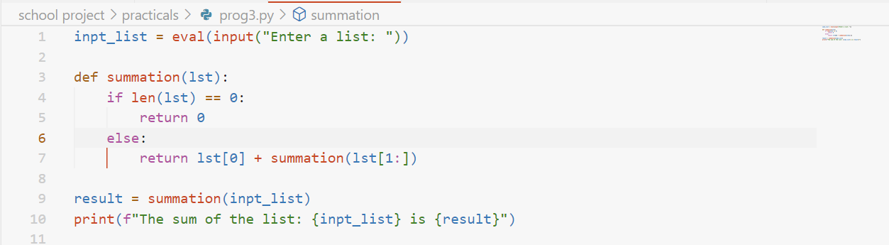

**OUTPUT: -**

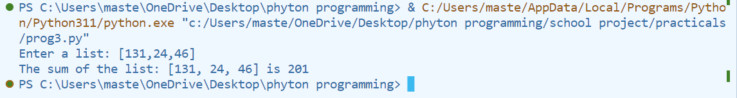

**PRACTICAL EXERCISE-3**

**Q: Write a program to calculate the nth term of Fibonacci series.**

**PROGRAM: -**

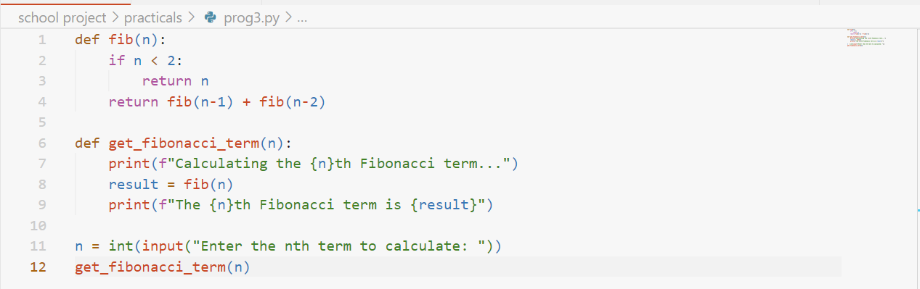

**OUTPUT: -**

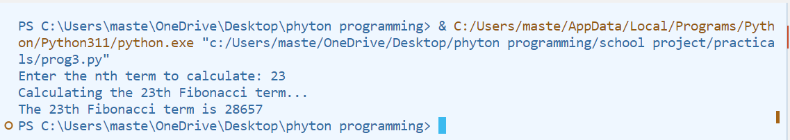

**PRACTICAL EXERCISE-4**

**Q: Write a program to search any word in given string or sentence**

**PROGRAM: -**

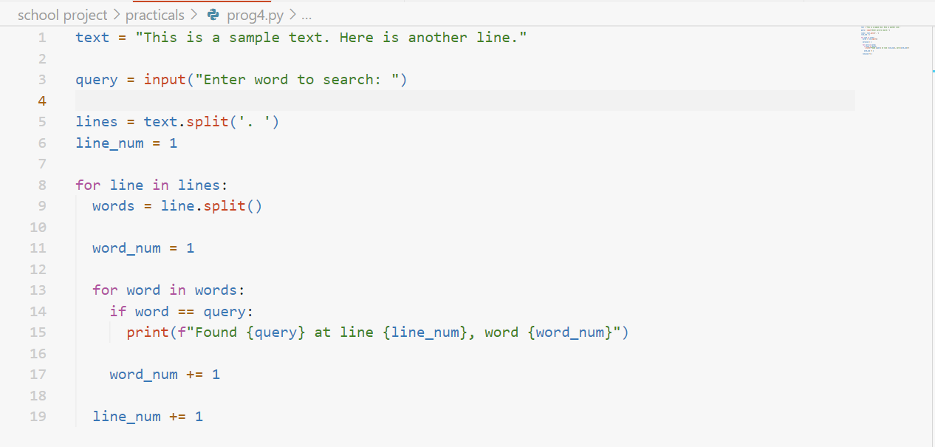

**OUTPUT: -**

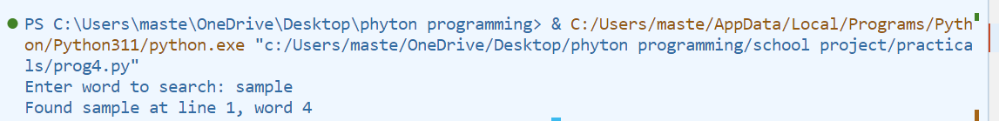

**PRACTICAL EXERCISE-5**

**Q: Write a program to read and display file content line by line with each word separated by #**

**PROGRAM: -**

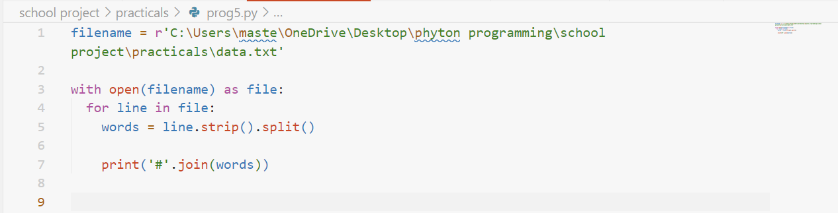

**OUTPUT: -**

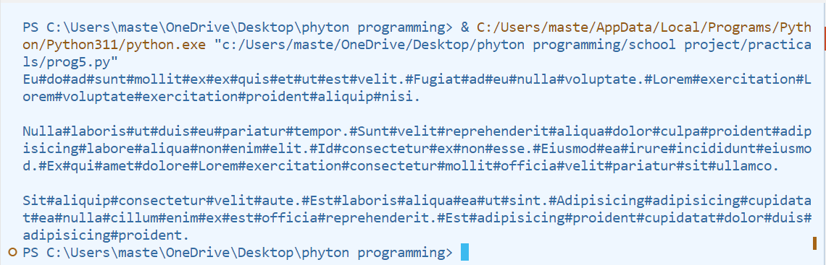

**PRACTICAL EXERCISE-6**

**Q: Write a program to read the content of a file and display the total number of consonants, uppercase, vowels and lowercase characters.**

**PROGRAM: -**

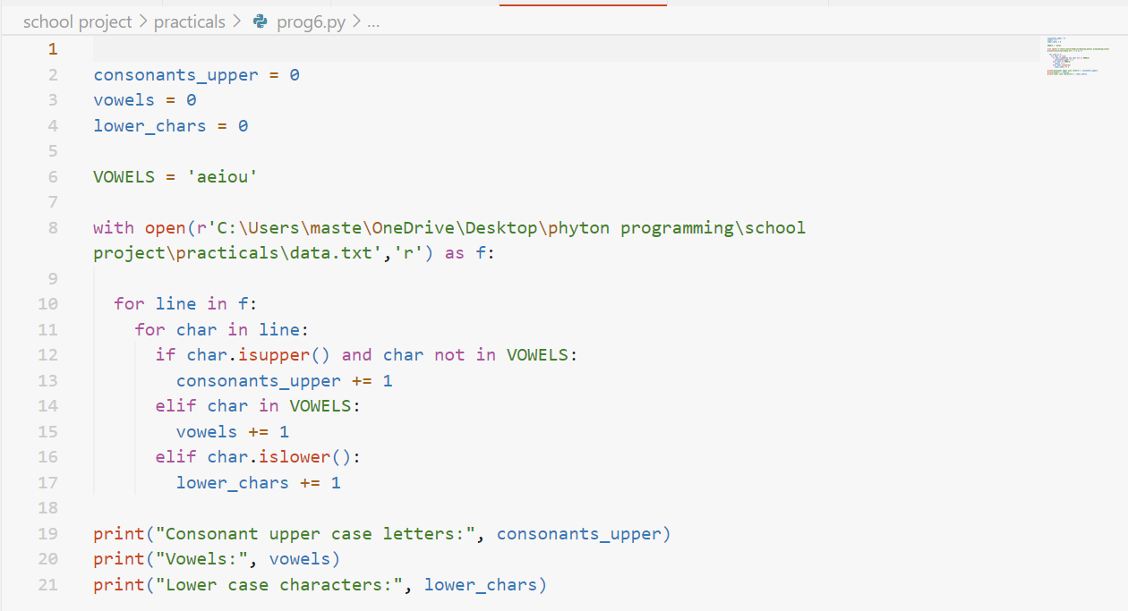

**OUTPUT: -**

